D.A.V. MODEL SCHOOL
SECTOR 15 A CHANDIGARH
CLASS-XII
CBSE RESULT 2021-2022

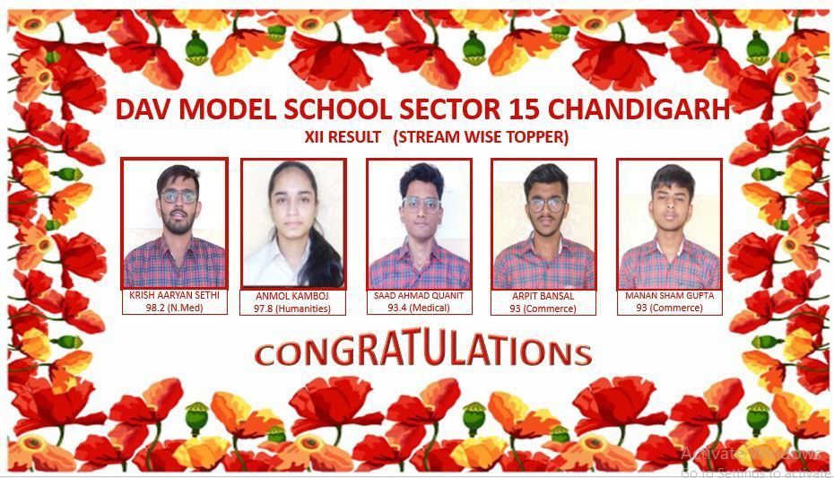

Stream wise topper
Arts
- Anmol Kamboj- 97.8 %
- Akshita Sharma- 95.6%
- Aadrika- 94.2%
Medical
- Saad Ahmad - 93.4 %
- Aditya Sharma- 90.8%
- Gurshaan Singh- 90.4%

Non-Medical
- Krish Aaryan Sethi- 98.2 %
- Dilbar Singh Lamba- 97.2%
- Vansh Abbott- 96.2%

Commerce
- Arpit Bansal & Manan Sham Gupta- 93 %
- Ricky Mittal- 92.6%
- Manish Kumar- 91.8%

DAV Model School Sector-15A, Chandigarh
CBSE RESULTS XII-SESSION 2021-2022

School QPI -80.45
1ST Position Krish Aaryan Seth (Non Medical) : 98.2 %
2nd Position (Anmol Kamboj – Arts) : 97.8%
3rd Position (Dilbar Singh Lamb – Non-Med) : 97.2%
4TH Position (Vansh Abbott – Non-Med) : 96.2%
No. of students above 90% : 25
No. of students above 80% : 80
No. of students above 75% : 100
No. of students above 70% : 120
First division 60% & above : 142
Overall School QPI : 80.45
Total Students Registered : 143
No. of students appeared : 143

