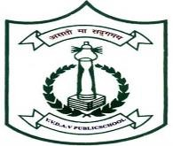
Veda Vyasa DAV Public School VikasPuri, New Delhi
Pre-Primary Monthly Plan JULY 2024
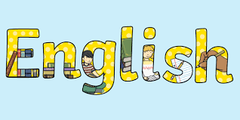
LANGUAGE SKILLS

English
- Listening and Speaking skills
- Recap of ‘a’ vowel words
- Phrases of ‘a’ vowel words(pg15) of IAB
- Introduction of ‘e’ vowel words

Simple Courtesies
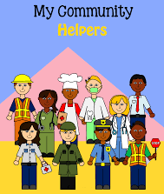
Hello, sorry, thank you, Good Morning, Good night, Good Afternoon, Good Night, Excuse me, bye, have a nice day.

Simple Sentences related to Water:
  - Water is important for all living things.
  - We need water for drinking, washing, cooking etc.
  - Water comes from various sources like river, ocean & lakes etc.
  - Water is colourless, odourless & tasteless
  - water related vocabulary- sink & float.

Sentences on Our Helpers
  - Doctors help us when we are sick.
  - Soldiers help to protect our country.
  - A fire fighter helps when there is a fire.
  - A teacher teaches students.
  - A postman delivers letters.
  - A mechanic fixes our vehicles
  - A Policeman catches a thief.

LISTENING AND SPEAKING SKILLS

Listening and speaking of-
  - “a” vowel words and phrases.
  - Rhyming words of “a” vowel; BE QUICK GAME

Rhymes from the “Rhythmic Rhyme Book”
  - Pg 45-Postman, Doctor
  - Pg.47-Cobbler
  - Pg. 21 & 23 - Water Rhyme

READING AND WRITING SKILLS
Reading and writing of-
- “a” Vowel words and phrases.
- My English Book Page No. 14 & 15.
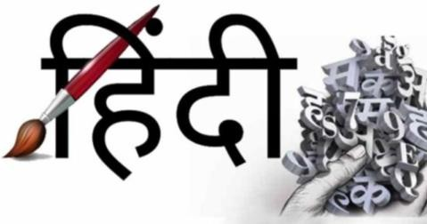
- Integrated Activity Book Page No. 15-18 and 25-28

- Hindi

LISTENING AND SPEAKING SKILLS
Listening and speaking of-
  - Stories related to व्यंजन ट - म
  - व्यंजन गीत
  - Songs and Rhymes related to E.V.S. topic - Our Helpers.

READING AND WRITING SKILLS
Reading and writing of- व्यंजन ट - म

Shabad Abhyas Book – up-to Page No.- 5 Bal Madhuri Book Page No.-1 – 5

COGNITIVE SKILLS BASIC CONCEPTS
  - Free hand drawing of four basic Flat Shapes.
  - Recognition of different flat shapes in surroundings.
  - Kindergarten Mathematics page No. – 55 to 60.

NUMBER CONCEPTS
  - What comes just after (0-10)
  - What comes just Before (0-10)

  - Between numbers (0-10)

ENVIRONMENTAL CONCEPTS

Integrated activity book
  - Water - Page no. 16 – 18
  - Our community helpers– Page no. 25-28

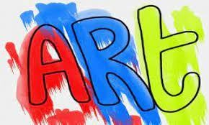
CREATIVE AND EXPRESSIVE ART

Art and Craft
- Use clay to make objects related to a vowel words like bat, cat, cap etc.
- Drawing and colouring of tools used by our helpers.

- Fun with colours – Page No. 3-8

MUSIC AND DANCE
Singing & Dancing on the theme song of VAN MAHOTSAV

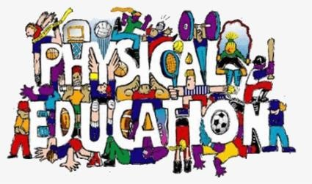
PHYSICAL DEVELOPMENT

Physical Education
- Flat race
- Tug of war
- Breathing exercises.

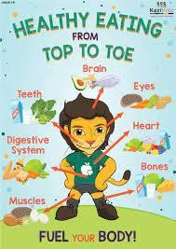
HEALTH, HYGIENE AND NUTRITION
- Trim your nails and hair.
- Drink lot of water and fluids like juices, lemonade etc
- Eat a bowl of seasonal fruits
- Throw trash in the dustbin only.
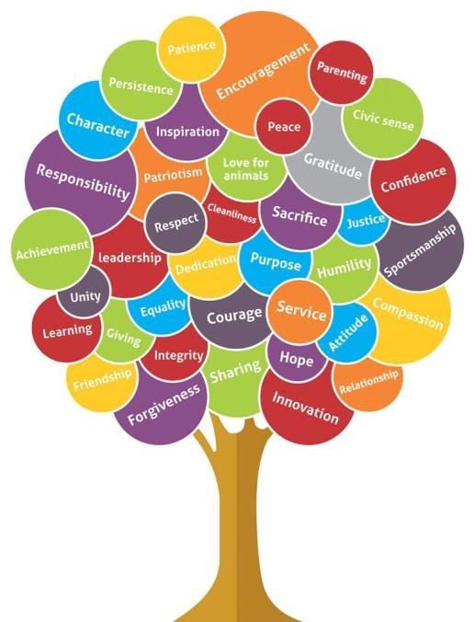
- Use apron and mat on daily at the time of lunch or any other art activity.

MORAL VALUES
- Cleanliness is next to godliness.
- Plant trees to save environment

Activities of the month
  - Vanmahotsav Celebration- 5th July
  - Hands on Experiment- 26th July

Value of the Month
h
  - Nature Love.

Habit of the month
  - Respect nature’s beauty.

.

