CONTENTS/ARTICLES FOR ZONAL MAGAZINE–ACTIONPLAN2022-23 DAVMMPSCGZONE-(F) & 5 SCHOOLS OF KONDAGAON
1. SCHOOL PHOTOGRAPH – WITH NAME/MONO/AFFILICAION NO FULL DETAIL WITH ADDRESS

SNO. | SCHOOLNAME | ADDRESS | WHOME THE SCHOOL IS SERVING
1 | DAV MUKHYAMANTRI PUBLIC SCHOOL | DAV MPS,VISHRAMPURI, BLOCK- BADERAJPUR, DIST- KONDAGAON (C.G) | It caters to the educational needs of tribal children who are primarily first generation learners.

2. SCHOOL HISTORY AND STRENGTH OF STUDENTS/STAFF

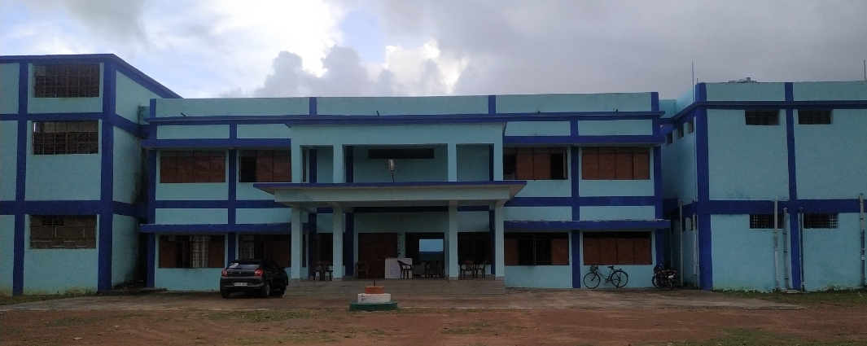

Dav Mukhya mantri public school Vishrampuri is located at rural area in the block- Baderajpur Dist.Kondagaon.The School is in fact in the woods. Supers imposed two storied building houses 16 teachers and 486 children. The school offers B P C /M P C and commerce subject’s up to Senior Secondary level under CBSE syllabus. It caters to the educational needs of tribal children who are primarily first generation learners.
Over a period of 06 years DAVMMPS Vishrampuri has succeeded in enhancing the roll strength, regularity of pupils, garnered in establishing rappo with parents, improving results of students especially for classes X and XII drawing best wishes of local authorities and above all clinching prizes in co-curricular activities at block and district level.
It is my pleasure to apprise at this juncture that the school possesses well trained and experienced teaching staff, who are dedicated and determined. They ensure to bring out the latent talents of the children and channelize it in desired direction. They undergo training conducted by CBSE and Dav Nodal Centre Raipur from time to time. Thus they update their skills and capacities.
Apart from regular teaching-learning process, the school imparts training on 21st century skills, soft skills to the students.
At present the school is striving to secure accreditation from Nabet-Qci a distinguished milestone and a rare privilege extended to few schools.
Thus in a nutshell, DAVMMPS Vishrampuri has carved a niche in the District. KONDAGAON and surely will achieve many more benchmarks in the days to come. Certainly the students will leave their footprints over the sands of time.

SNO. | STRENGTH
SNO. | STUDENT | STAFF
2020-21 | 486 | 17

3. RESULT OF BOARD CLASSES – LAST FIVE YEARS

SNO. | SESSION | X RESULT |  | XII RESULT
SNO. | SESSION | QUALITATIVE | QUANTITATIVE | QUALITATIVE | QUANTITATIVE
1 | 2016-17 | 100% | 100% | 0 | 0
2 | 2017-18 | 100% | 97% | 100% | 59%
3 | 2018-19 | 100% | 97% | 100% | 23%
4 | 2019-20 | 96.55% | 94% | 100% | 39%
5 | 2020-21 | 100% | 100% | 100%S | 100%

4. A SPECIAL ACHIEVEMNTS/INNOVATIVE SESSION IDEAS FOR DEVELOPMENT OF STUDENTS- (*PHOTOGRAPH, COLLECTION REGARDING NEWSPAPER CUTTING REPORT). LAST FIVE YEARS

SNO. | SESSION | AREA | CERIFICATE | APPRECIATION

5. SOCIAL AWARNESS ACTIVITIES - LAST FIVE YEARS (*PHOTOGRAPH, COLLECTION REGARDING NEWSPAPER CUTTING REPORT) .

S.NO | SESSION | DATE | THEME FOR AWARNESS CAMPAIN | APPRECIATION
01 | 2019 | 02/10/2019 | SOCIAL AWERNESS ABOUT PLANTATION & CLEANLINESS | STAKE HOLDER OF SCHOOL
02 | 2021 | 19/02/2021 | AWARNESS ABOUT FUTURE PLANING THROUGH CARREAR CONCILLING | DISTRICT EDUCATION OFFICER & DR.NEETA MISHRA,KONDAGAON
03 | 2021 | 03/09/2021 | AGGRICULTURAL WORK SHOP | NGO,(SANGENTA )
04 | 2021 | 04/11/2021 | SCIENCE EXHIBITION | STAKE HOLDER OF SCHOOL
05 | 2021 | 20/9/2021 | MEDICAL CAMP | CHIEF MEDICAL OFFICER ,VISHRAMPURI
06 |  | 23/09/2021 | ELECTRICTCAL AWARNESS CAMP | CSEB, VISHRAMPURI

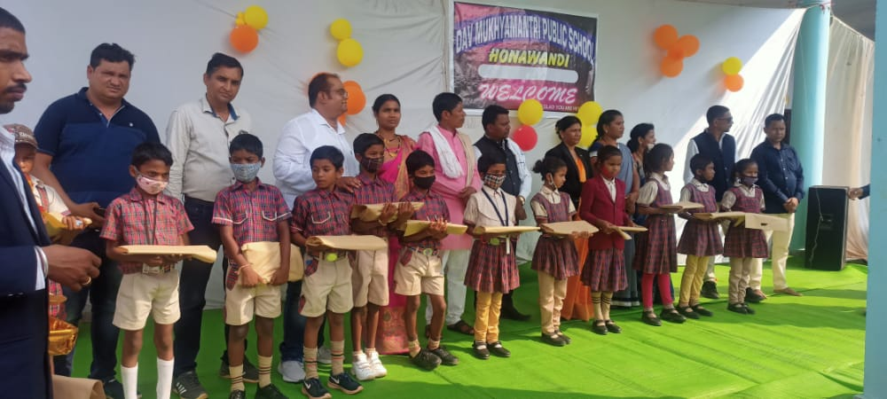
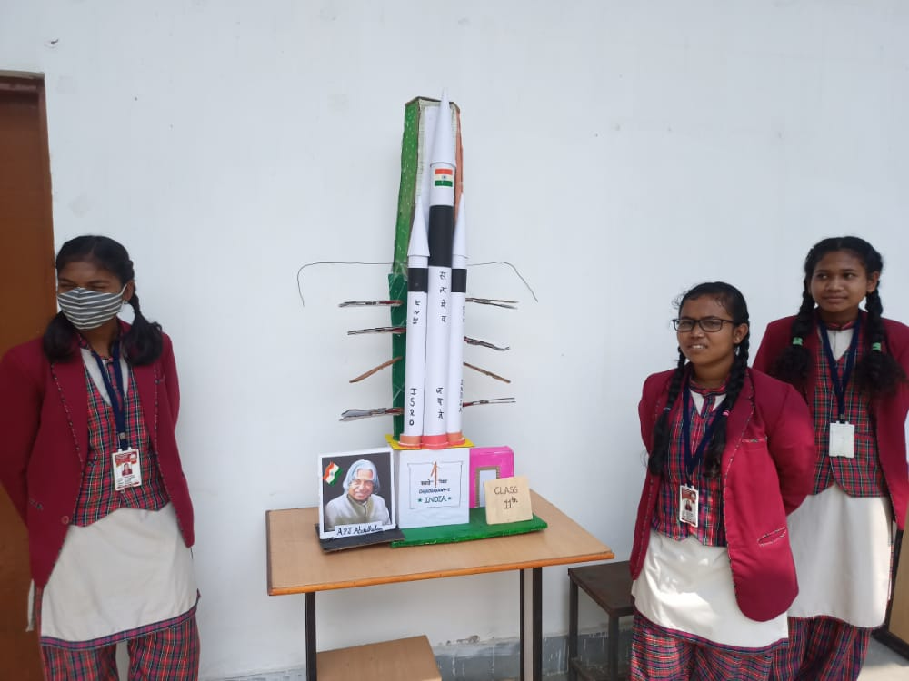
PRESENTATION FOR INNER STRENGHT
SUPPORTERS COME OUT FOR THE SOCIAL ASSISTANCE

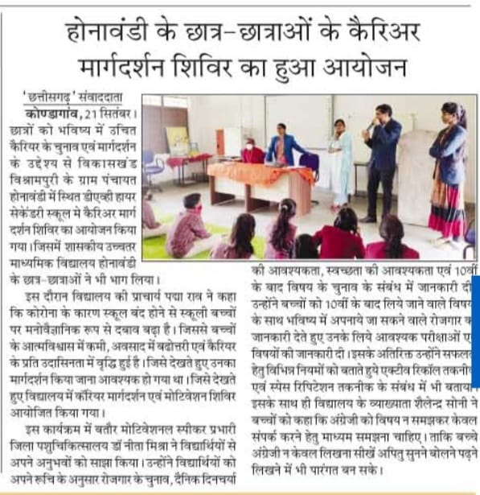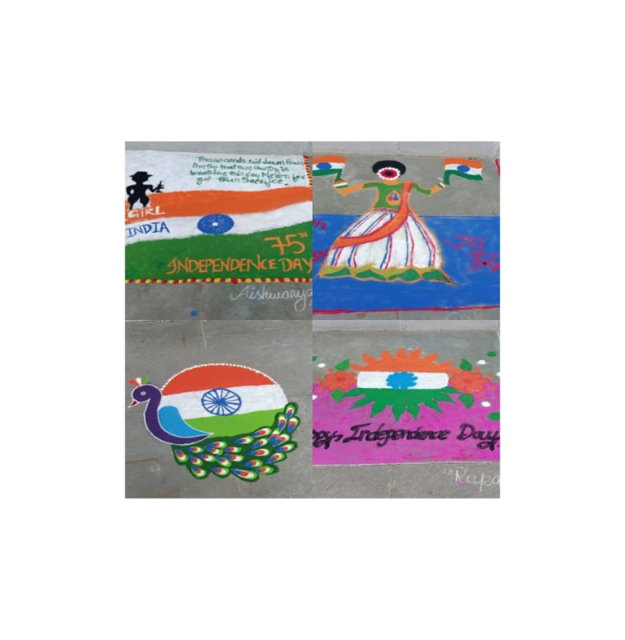
PANITION AXHIBITION BY SCHOOL
CARRER CONCELLING ORGNISED BY SCHOOL

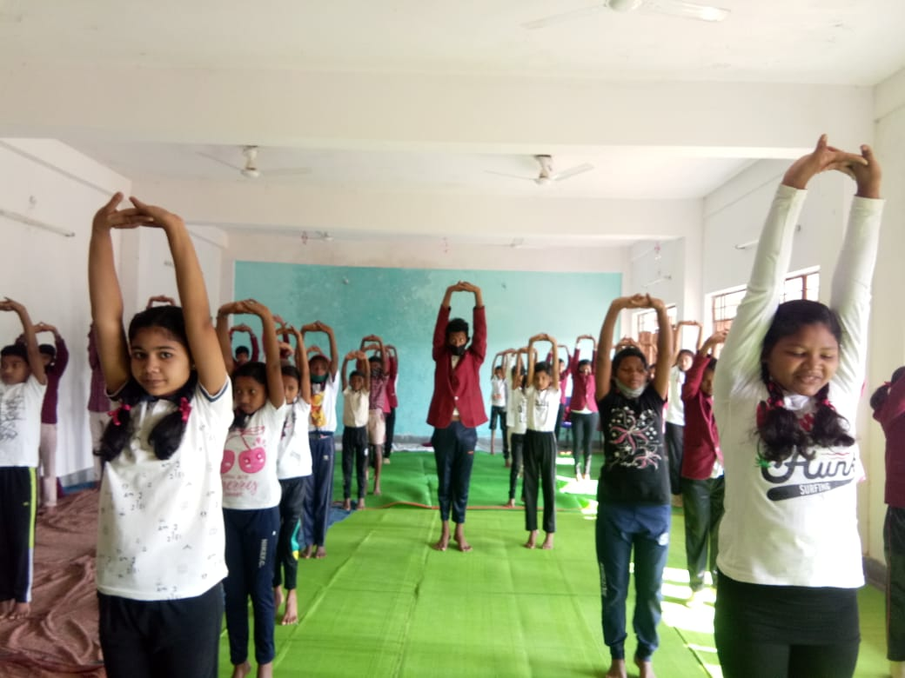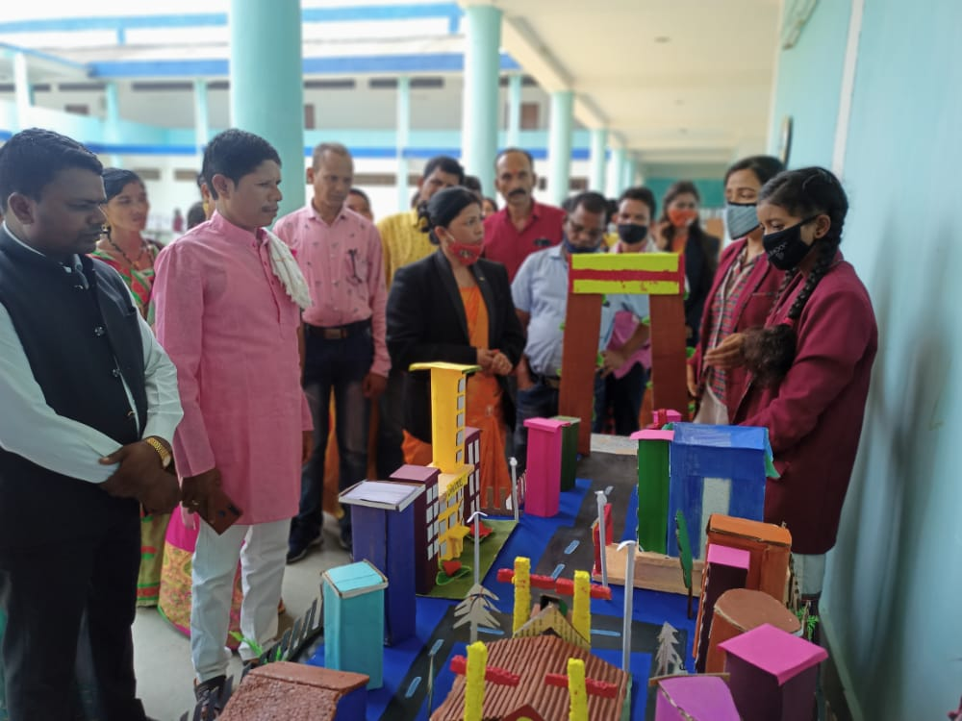
SCIENCE EXHIBITION
PHYSICAL EXERCISE ORGNISHED BY THE SCHOOL AS YOGA

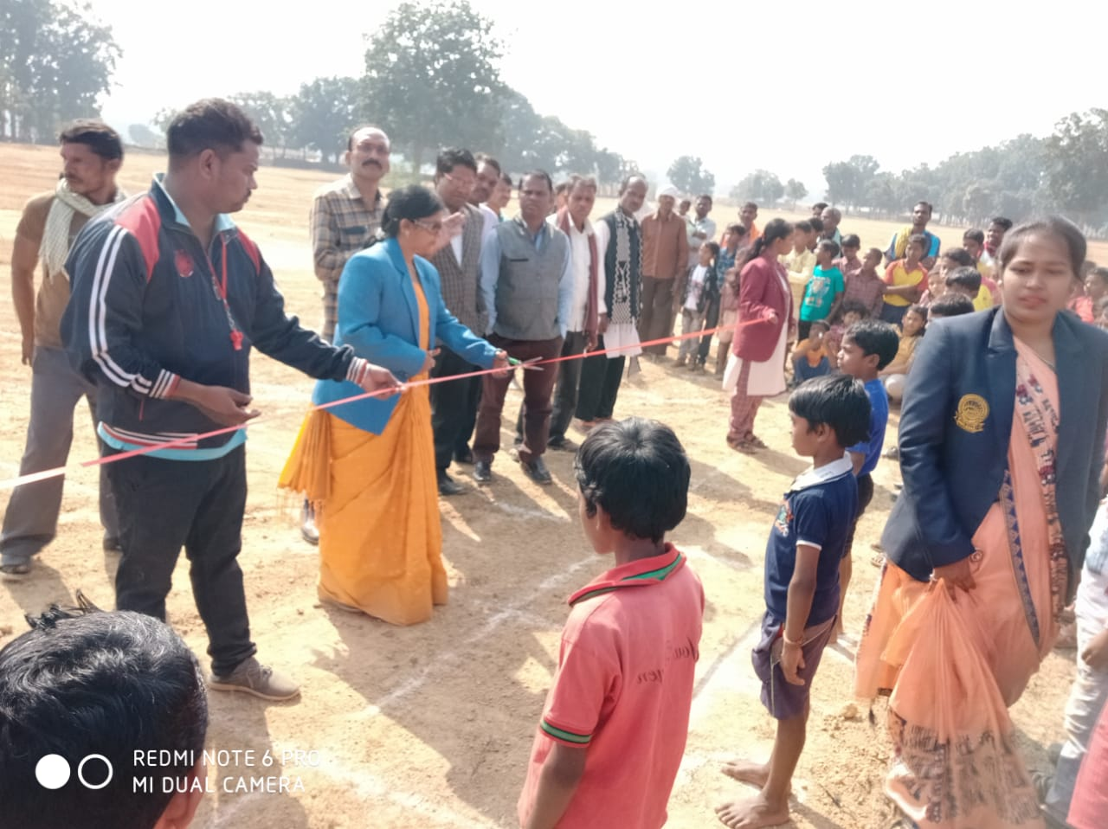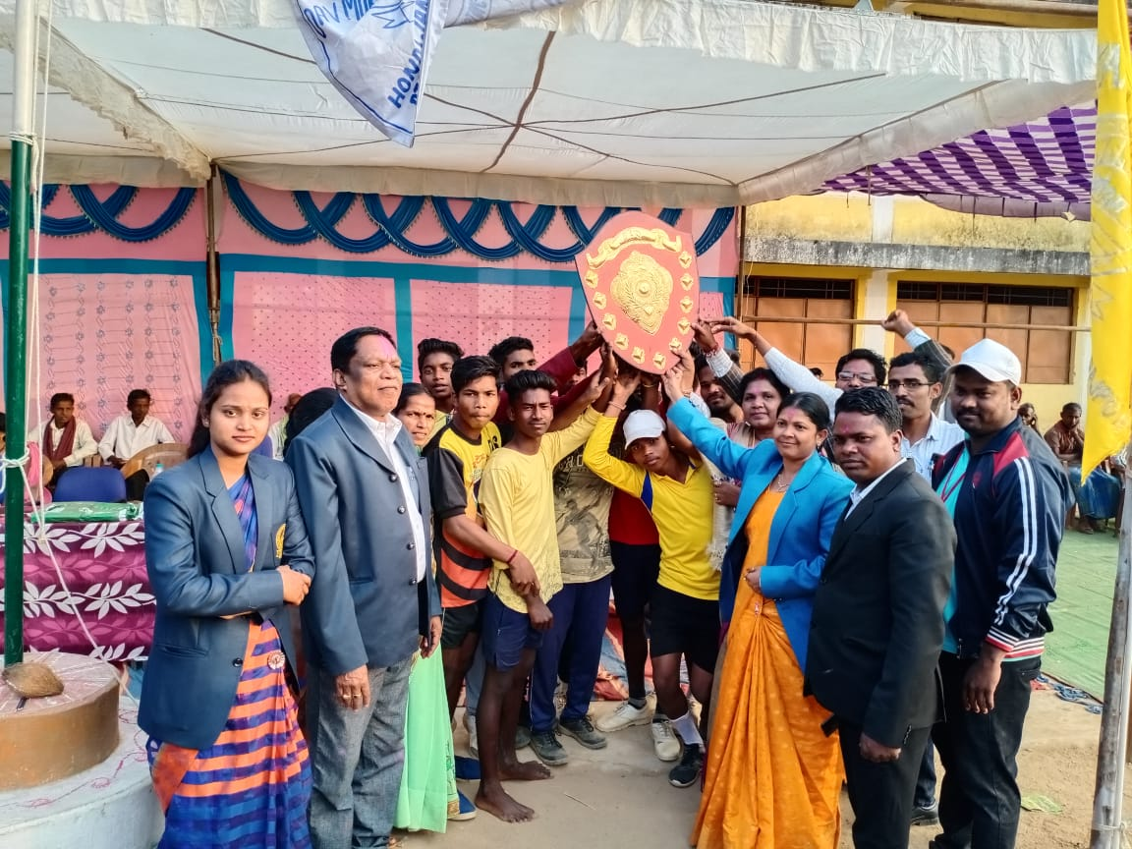
CONTESTANT WHO WINS THE 1ST POSITION
SPORTS ACTIVITES CONDUCTED BY SCHOOL

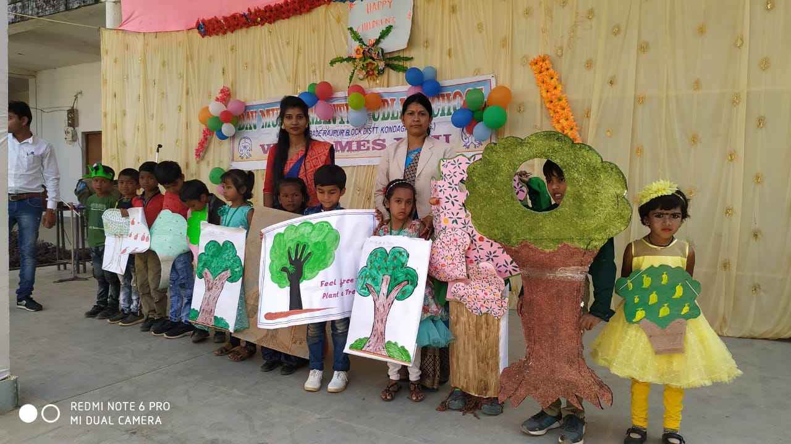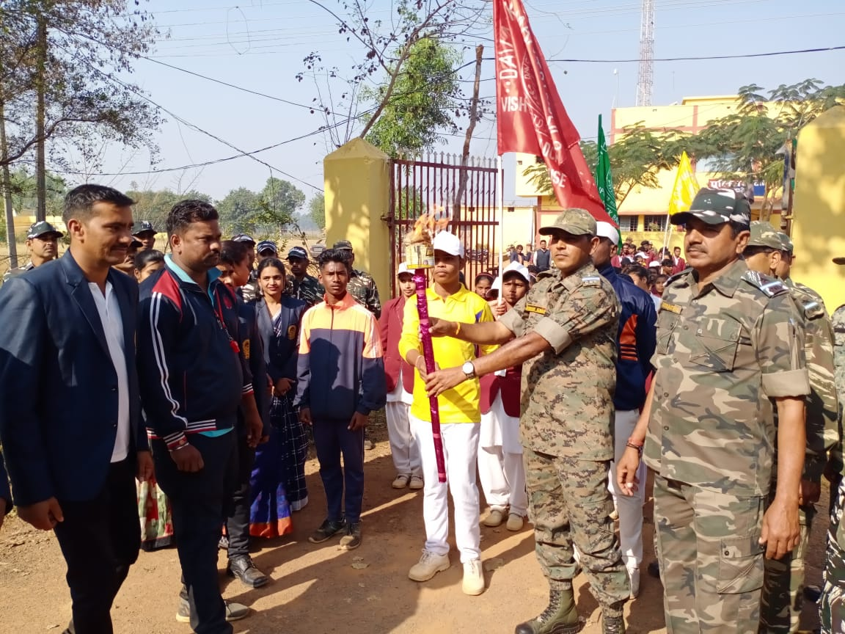
SPORTS INAUGURATION BY CRPF COMMANDENT
ENVIRONMENTAL AWARNESS

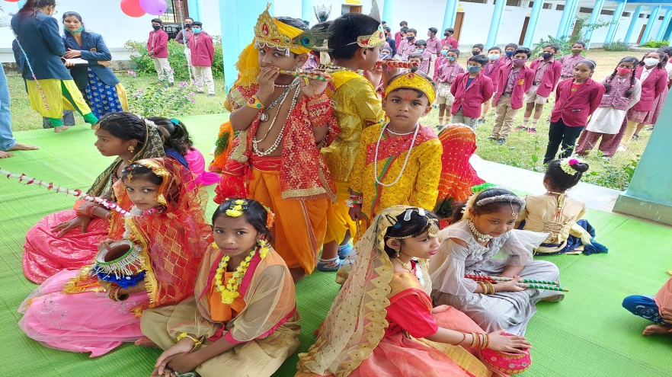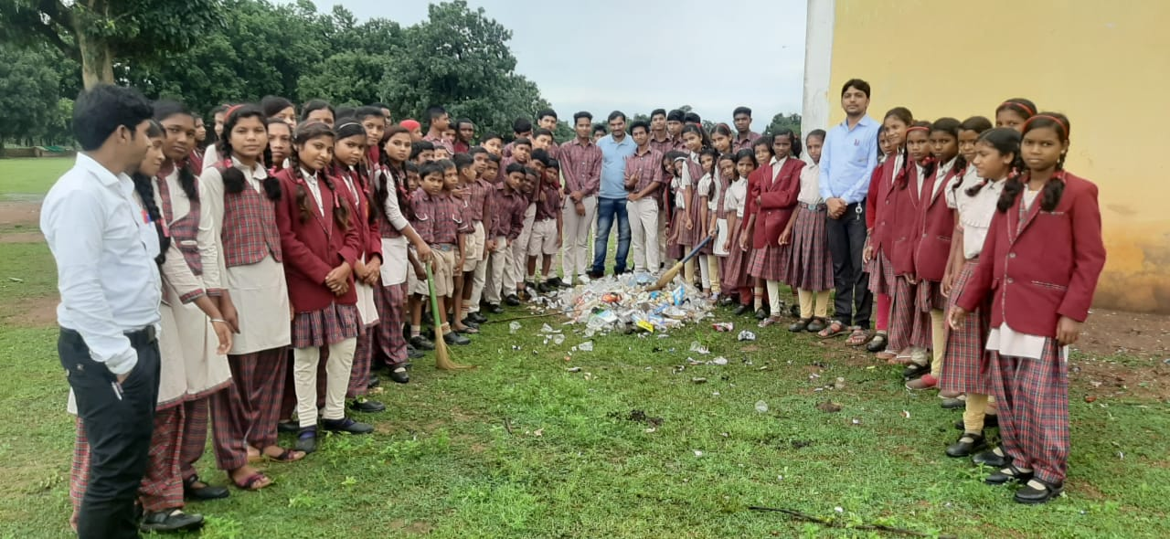

S

