English
Home Assignment for Summer Vacation Note : Do your H.W on White A3 Size Sheet.
Roll no 1-10 Prepare a poster on Digital India
Roll No 11 -20 : Prepare a greeting card for a physically disabled person with a positive message written on it.
Roll No 21-30 – Write a slogan on” Women Empowerment “.
Roll 31-40 – Prepare a book cover of your book Beehive
Roll No 41-48 Prepare a book cover of your book Moments

Larning work – Learn and revise the syllabus periodic test t be held in july after the vacation

Hindi
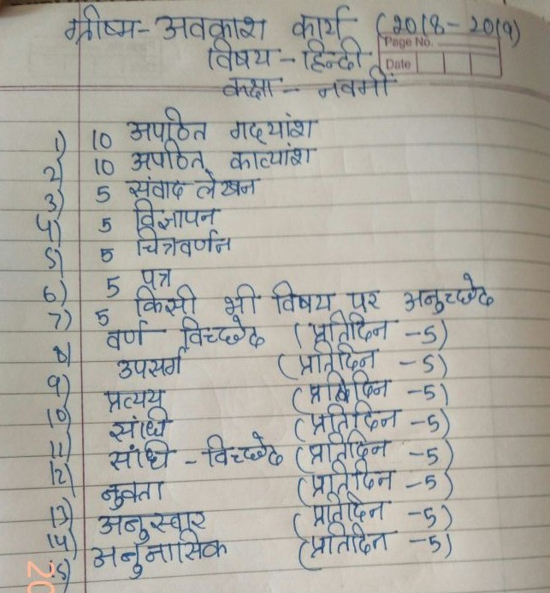

Maths : Do all the questions given in NCERT Maths Exampler Book for the chapters taught to you in the class in separate Notebook .
Science : Do all the questions given in NCERT Science Exampler Book for the chapters taught to you in the class in separate Notebook .

S.SC
Project on disaster management is compulsory for all the students .
Guidelines for the project
- Project to be done in activity file.
- Project should be hand written 5-10 pages.
- Newspaper cuttings , maps , diagrams , illustrations are must.
- Index/ contents with page no. and acknowledgement is also must.
Topic 1- Make a project on Earthquake prone areas in India – causes , impact on life and property , mitigation strategies used to reduce the impact of the earthquake. ( Roll 1-10)
Topic 2 - Project on areas prone to cyclone in India – warning system , effects of cyclones , mitigation strategies to be used while construction of buildings .( Roll 11-20)
Topic 3 – Survival skills during and after disaster ( Roll 21-30)
Topic 4- A brief pocket guide on ‘First Aid. Roll no (31-40)
Music
Learn sargam 7,8,9,10
Paste pictures of singer , vocalist and actors in your notebook any five.

Computer
- Make a chart on Cybercrime
Art

Decorate a mirror with the help of broken CD , Beads , Pebbles and M- seal . Color it with glass colors as shown in the picture.

