DAV PUBLIC SCHOOL KHERA KHURD / BUDHPUR
School Website : davpskherakhurd.com , School Tel No. 01127844245 , 01127201930

SUMMER BREAK HOLIDAYS HOMEWORK
Class-V
English
- Make a graphic organizer chart with pictures on different types of nouns .
Group A : Countable and uncountable noun
Group B : Common and proper noun
Group C : Collective nouns
Group D: Abstract and Concrete noun
2. Project
Design an English magazine which should include following things:
- give a creative name to the magazine
- cover page
- a small story
- puzzles
- crossword
- cartoon strip
- advertisement
- ( you can use computer to design your magazine)

हिंदी
१) भारत के एक ऐतिहासिक स्थान ( ग्रुप के अनुसार ) का चित्र बना कर रंग भरें। उससे संबधित निम्नलिखित जानकारी लिखिए।
- भारत के किस राज्य में स्थित है ? ग्रुप १) स्वर्ण मंदिर
ख) शहर का नाम ग्रुप २) चार मीनार
ग ) कब बना ? ग्रुप ३) sun टेम्पल
घ ) किसने बनाया? ग्रुप ४) अजंता - एलोरा की गुफाएँ
ड ) प्रमुख विशेषताएँ
2) हर बच्चे का कोई न कोई सपना अवश्य होता है। आप भी अपने लक्ष्य के बारे में कुछ पंक्तियाँ लिख कर चित्र सहित
दर्शाएँ।
३) चित्र सहित कोई एक कहानी लिखिए। और उससे संबधित निम्नलिखित जानकारी लिखिए---
क) लेखक का नाम
ख ) मुख्य पात्र
ग ) शिक्षा

Maths
Project
Population of 4 Metro Politian cities/ 4 Union Territories/ 4 smallest states/4 largest states of India.
Now do the following question.
- Find out total population of given states
- Highest populated city/state.
- Least Populated city/ state.
- Find out the difference between Least and highest populated city/ state.
Activity
Collect the Electricity bill /Water bill/ Grocery Bill/ Telephone bill of 3 months of your home. Read it carefully and answer the following question.
- Total units/ total expenditure in last 3 months.
- In which month the consumption was highest.
- In which month the consumption was minimum and by how much?
- Write 5 ways to save energy/water/ food/ reduce the bill.

Note:- Group wise distribution of project and activity.
Rose/ Juice – 4 Metro Politian cities and Electricity bill
Jasmine/Jam- 4 Union Territories and Water Bill
Lotus /Sauce- 4 Smallest States and Grocery Bill
Lily /Pickle- 4 largest states and Telephone bill

Science
Activities would be done roll number wise in groups which are already allotted to the students.
Group 1- Rose/Jam (Rollno-1-5)
Group 2- Jasmine/Sauce(Rollno-6-10)
Group 3- Lotus/Pickle (Roll no- 11-15)
Group 4- Lily/Juice ( Roll no- 16- 20)
Activity 1- Paste pictures of any two plants which are reproduced through following ways and write the names of the plants.
1)Reproduction through leaves. Group 1- Rose/Jam (Rollno-1-5)
2) Reproduction through underground stem. Jasmine/ Sauce(Rollno-6-10)
3) ) Reproduction through roots. Group 3-Lotus/Pickle (Roll no- 11-15)
4) Reproduction through stem cutting. Group 4- Lily/ Juice( Roll no- 16- 20)
Activity -2- Paste wrappers or label of juice, pickle, jam and sauce and write the name , ingredients,
preservatives and nutritive value of the item allotted to you .
Group 1- Rose/Jam (Rollno-1-5)
Group 2-Jasmine / Sauce (Rollno-6-10)
Group 3- Lotus /Pickle (Roll no- 11-15)
Group 4- Lily/Juice ( Roll no- 16- 20)

Social Science
1) Paste the pictures of different types of houses and write the important features
Group A : Houses in Hilly Areas
Group B : Houses in Coastal Areas
Group C : Houses in Earthquake prone areas
Group D: High-Rise apartments.
2) Project
Make a newsletter on Kailash Satyarthi who received Nobel Peace Prize of 2014 for working hard in the sphere of child Labour. It should include the following things:
- Creative name
- His education and life
- Pictures of his work
- His work for children
- His achievements
- His Bharat Yatra
Sanskrit
- Group A पठ के धातु रूप लट लृट में में स्मरण कीजिए।
- Group B बाल शब्द के रूप फाइल म लिखिए।
- Group C किन्ही चार वाहनों के नाम संस्कृत में लिखिए और चित्र चिपकाएं।
General Knowledge
Q1. Collect the information about Extinct or Endangered animals. Also paste pictures of them. (Min . 5 animals)
Q2. Make a project file, on each page, Paste pictures of great personalities of the world and India(Any five each). Also write what is common among all these great people

Music :
Learn the following :
- Sargam 1,2,3,4,5
- DAV Anthem
- Prayer teri hai zameen
- Mantras

Computer:
Make a chart on any one
- Memory devices of computer
- Peripheral devices of computer
Take light green color pastel sheet and use the sheet in landscape .The border of the sheet
should be of black colour .
Art
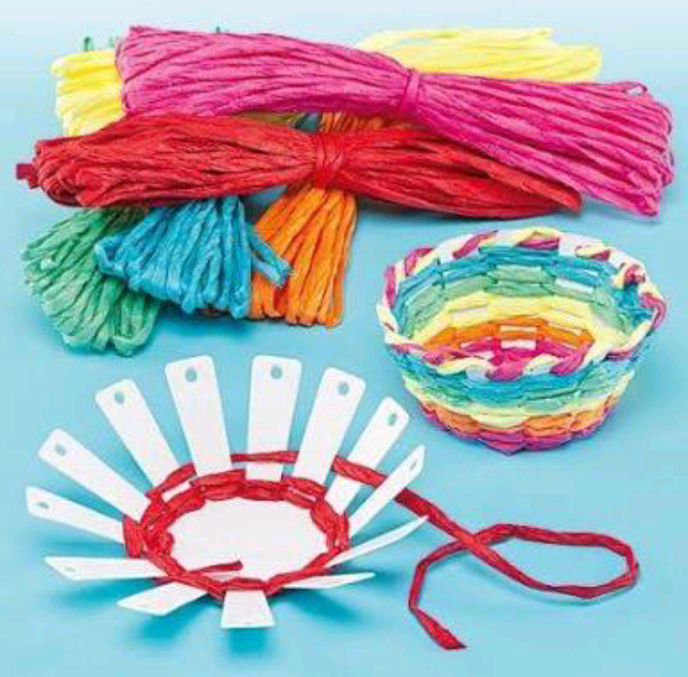
Make a basket with plastic bottle and wool as shown in the picture .

Vedpath
1. महारानी लक्ष्मीबाई के जीवन पर लेख लिखे।
2. यज्ञ प्रार्थना स्मरण कीजिए।
3. प्रातः शाम १५ मिनट के लिए मैडिटेशन कीजिए।

