DAV PUBLIC SCHOOL KHERA KHURD / BUDHPUR
School Website : davpskherakhurd.com , School Tel No. 01127844245 , 01127201930

SUMMER BREAK HOLIDAYS HOMEWORK (2018-19)
Class VIII

English
HOLIDAY HOMEWORK WILL BE ASSESSED FOR 5 MARKS Each subject
- Writing a self composed poem on “ My Mother”
- Read the unit “Changing Times” of “ My English Reader” and write a speech on “Impact of Media on Teenagers” in about 100-150 words
(Note- H.W. must be done in your activity file.)

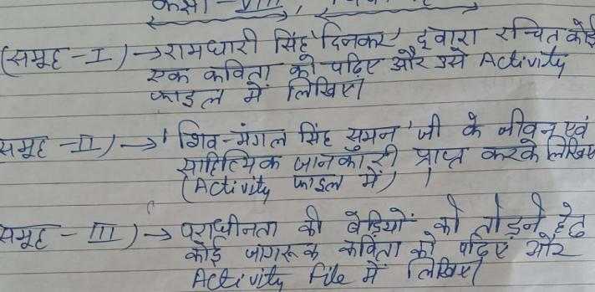
Hindi

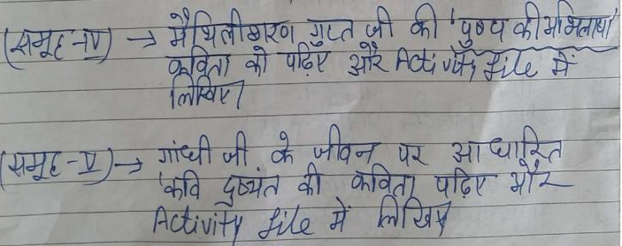

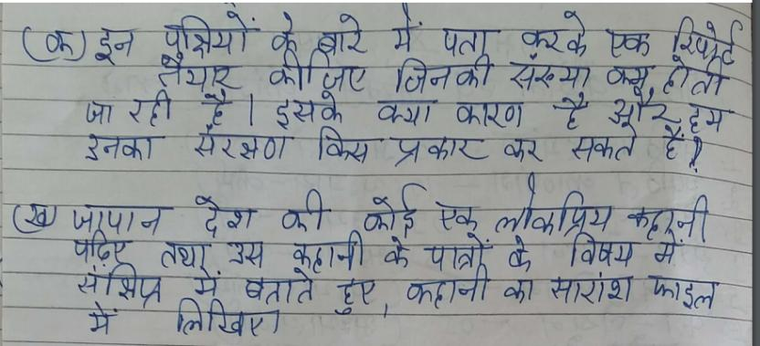
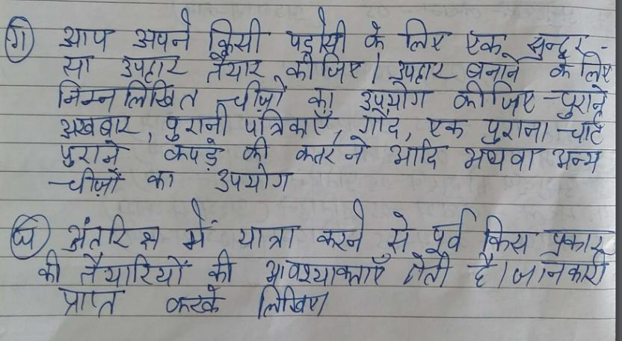

Maths

1) ACTIVITY:
List your P T1 marks in various subjects in tabular form and represent
it in the form of bar graph by paper cutting and pasting.---------------(2.5 M)
2) PROJECT:
Create a life history of Indian Mathematician and his contribution in
the field of Mathematics. .------------------------------------------ (2.5 M)
i) Group 1 Aryabhatta
ii) Group 2 Srinivasa Ramanujan
iii) Group 3 Brahmagupta
iv) Group 4 Bhaskara
v) Group 5 Varamihir
3) Do daily ten questions from the following chapters in a separate register
1) Squares and square roots(Brain teaser)
2) Cubes and cube roots (Brain teaser)
3) Direct and Indirect variation (Brain teaser)

G.Science
SEA (SUBJECT ENRICHMENT ACTIVITY) :-2.5 MARKS
Group | Activity
A | To study the features of earthquake safe buildings(also paste two pictures.)
B | Methods of increasing friction.
C | Methods of decreasing friction.
D | Different ways of food preservation.

Project :- ( 2.5 MARKS)
Group | Project
A | To make a model of voltaic cell.
B | To make an electromagnet.
C | To make a model of electrolysis of water.
D | To make a model of electroplating.

S.Science
Project. Visit a state monument during summer vacation and make a project on it highlighting it's location,who built it and why was it built?
Paste pictures to beautify it.
2.Activity
Prepare a report on National Park of India giving information about their location,bird or animal which are protected there
Group A Gir National Park
Group B Jim Corbet National Park
Group C Kaziranga National Park
Group D bandi pur National Park

Sanskrit
Group -A क्त्वा, ल्यप्, तुमुन् प्रत्ययानां दश-दश उदाहरणानि लिखत I
Group -B दीर्घ सन्धेः एतेषां उदाहरणानि वाक्यसहितं लिखत-
अ+अ= इ+इ= उ+उ=
अ+आ= इ+ई= ऊ+उ=
आ+अ= ई+इ= उ+ऊ=
आ+आ= ई+ई= ऊ+ऊ=

Group -C किम्, एतत्, तत् एतेषां त्रिषु लिङ्गेषु रूपाणि लिखत I
Group -D भू, गम्, पठ धातुनां पञ्च लकारेषु रूपाणि लिखत I

General Knowledge
Paste National , International and Sports News ( 10 each) in your G.K. Copy.

Computer
- Make a 3D model on online paying applications
Or
- Online Shopping Sites
Use Eco- friendly things only.

Music
Learn
- Sargam 6,7,8,9
- Write the biography of tansen in your music notebook
- Paste pictures of 5 singers with their names in you music notebook.
Art
Decorate a bottle with broken CD , beads , pebbles and M - seal .Color it with glass colours as shown in the picture.


Vedpath
- निम्नलिखित चार्ट बनाइए।
- हवन करते हुए चित्रों में दर्शाइए।
- परोपकार पर श्लोक लिखिए।
- विद्या पर पांच श्लोक लिखिए।
- मित्र पर पांच श्लोक लिखिए।

