KINDERGARTEN
Holiday homework for winter vacation
(2015-2016)

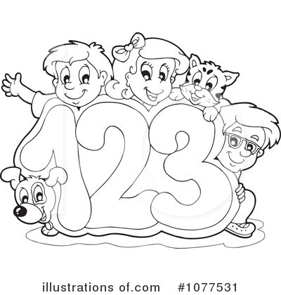

डी. ए.वी पब्लिक स्कूल
सेक्टर-6 द्वारका
रेफ़रन्स न. ………………….. दिनाक …………………
नाम ……………………. कक्षा…………………..
चित्र देख कर अक्षर लिखो
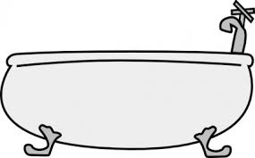
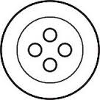

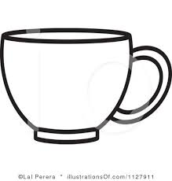

रिक्त स्थान भरो
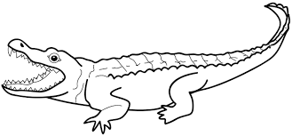
मग 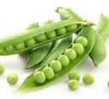 टर
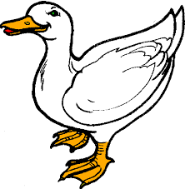
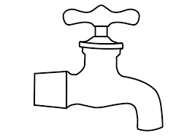
ल बत

लय वाले शब्द
महल - चमक-
नरम - सड़क -

डी. ए.वी पब्लिक स्कूल
सेक्टर-6 द्वारका
रेफ़रन्स न. ………………….. दिनाक …………………
नाम ……………………. कक्षा…………………..
शब्द लिखो
दो वर्ण तीन वर्ण चार वर्ण

DAV Public School
Sector VI,Dwarka,New Delhi
Ref.no. _________________________ Date _________
Subject- English
Name _________________________ Class- Pre Primary ____
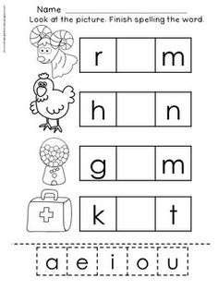
Write the correct vowel in the given box to make a word.

DAV Public School
Sector VI,Dwarka,New Delhi
Ref.no. _________________________ Date _________
Subject- English
Name _________________________ Class- Pre Primary ____
Look at the picture & make a word from the given letters.
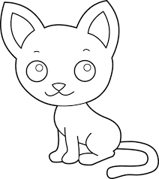 | c  a  t  m  i  x | cat
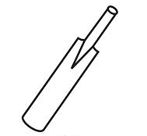 | b  a  t  k  o  j
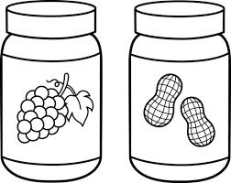 | c  i  t  m  a  j
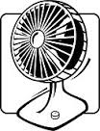 | f  e  p  n  a  t

DAV Public School
Sector VI,Dwarka,New Delhi
Ref.no. _________________________ Date _________
Worksheet
Subject- EVS
Name _________________________ Class- Pre Primary ____

- Draw the tools of each helper in the space provided?
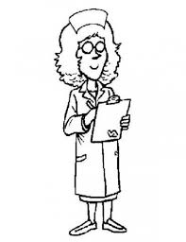
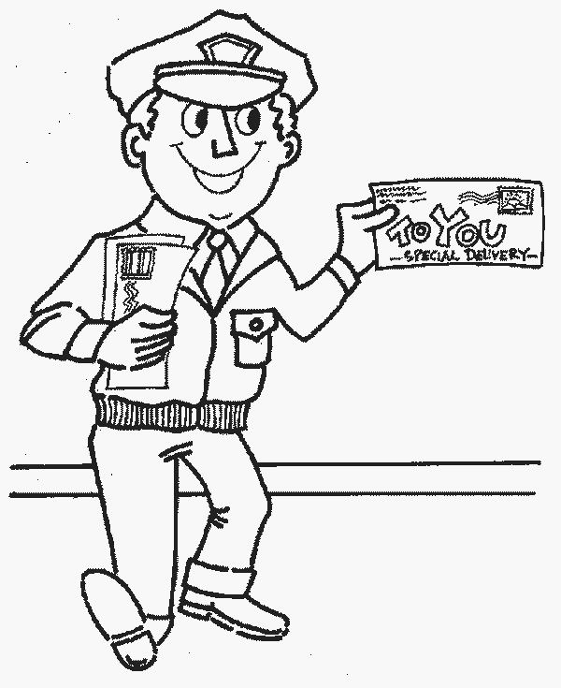
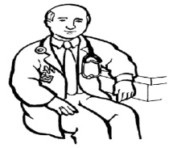
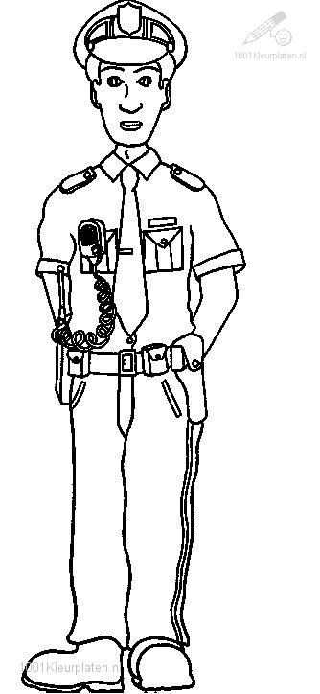

- Match the animals with their homes?
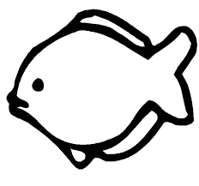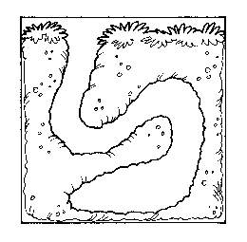
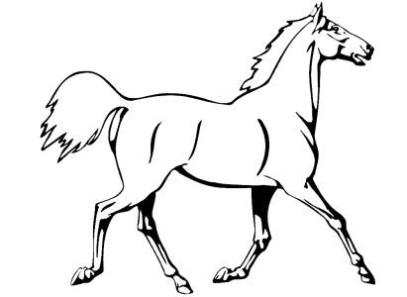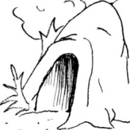
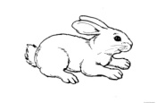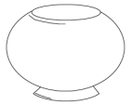
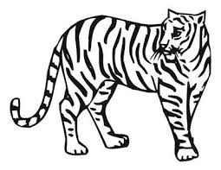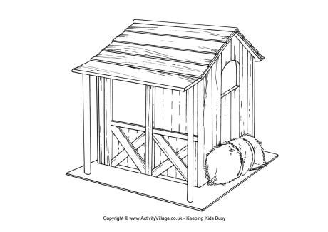

- Label the different parts of a plant?

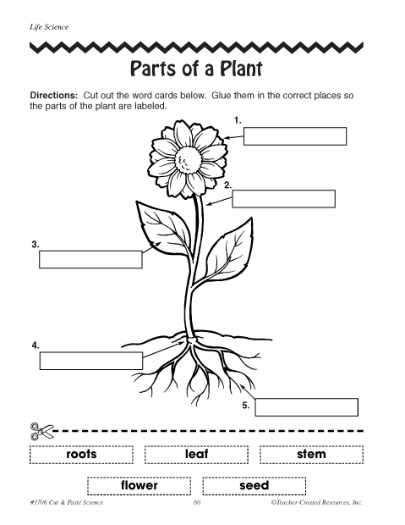

- Draw a circle on living things and cross the non living things?
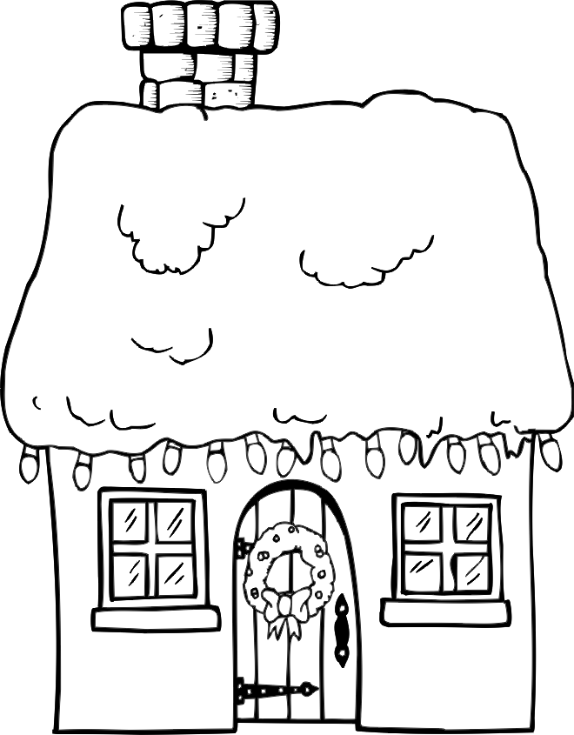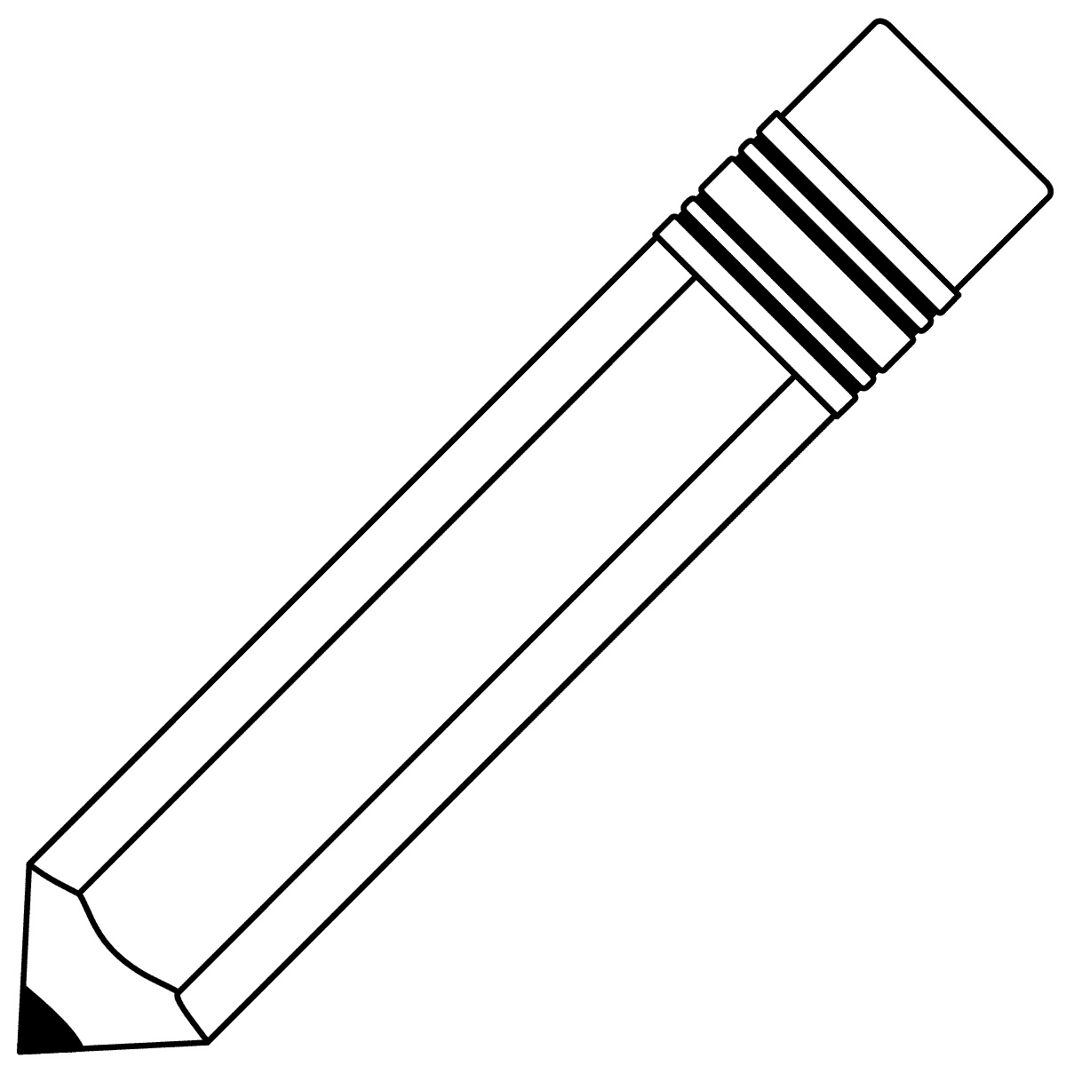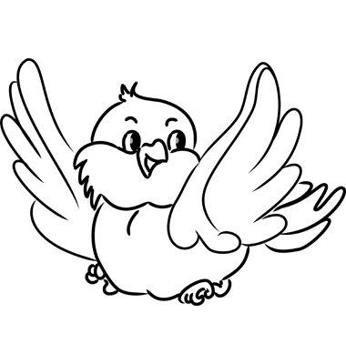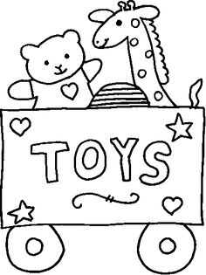

- See the below pictures and write W for water transport, L for land transport and A for air transport?

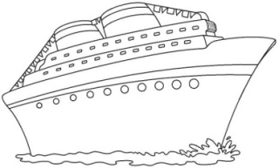
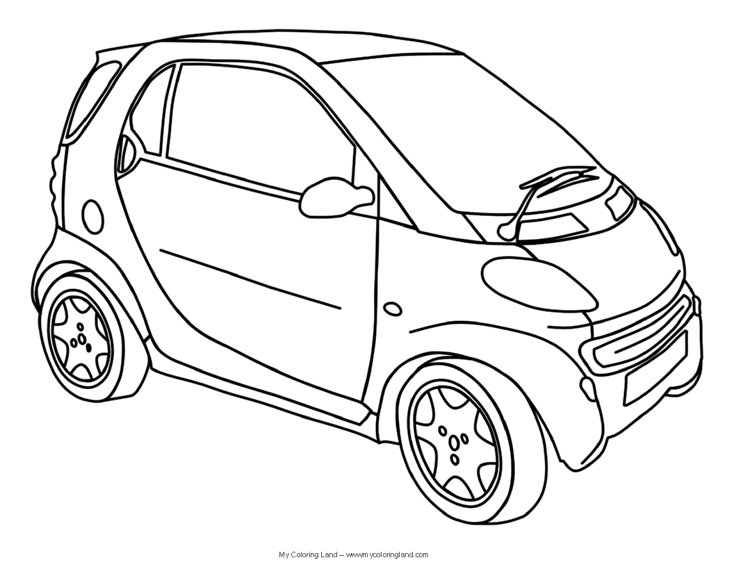

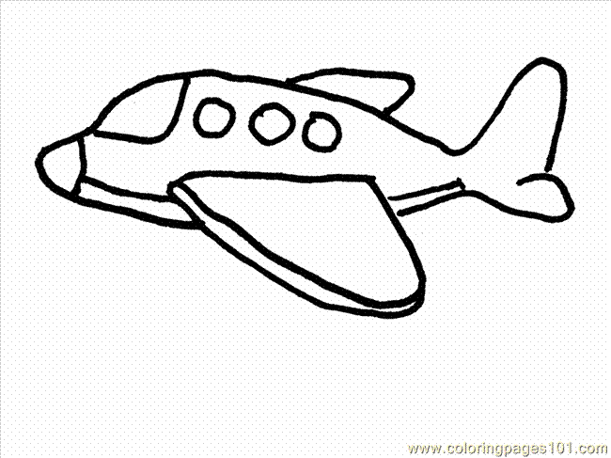

D A V Public School
Sector-6 Dwarka, New Delhi-110075
Date-_____________
WORKSHEET
Subject: Mathematics
Name-____________ Class-Pre-Primary

Q1. Fill the missing numbers.
- 59 __________ _________ 62 ___________ __________
- 88,89 ___________ ____________ ___________ 93
Q2. What comes
Before After Between
________ 74 46 ________ 39 _________ 41
________ 30 51 ________ 79 __________ 81
Q3. Solve.
13 16 11 14 17
+ 5 - 8 + 7 - 4 - 0
_______ _______ ________ _______ _____

Q4. Mental Maths
- 10 - 5 = ________
- 12 - 6 = ________
- 13 + 4 = ________

Q5. Concept of tens and ones.
9 30 96

T O T O T O
Q6. Draw the beads on abacus.
T O T O T O

______________56 __________40 ______6

Q7. Draw two objects of each
- Light weight

_________________ ____________________

- Heavy weight

___________________ ______________________

Join the dots from 1 to 50 in sequence and complete the picture. Now color it.
