KINDERGARTEN
Holiday homework for winter vacation
(2015-2016)

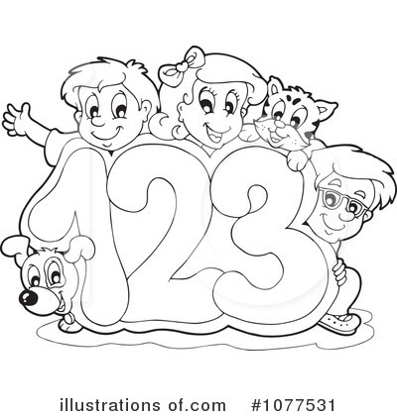

DAV Public School
Sector VI, Dwarka, New Delhi

Ref.no. _________________________ Date _________
Subject- English
Name _________________________ Class- Pre School____

- See the picture and write the initial letters.
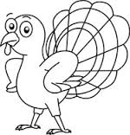




- Write the missing letters.

a |  | c |  | e
 | g |  | i
k |  | m |  | o

- Draw 2 pictures of each alphabet.

b
n
q

- Match the following.
    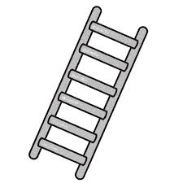   | c  f  p  l

- Write a-r

DAV Public School
Sector VI,Dwarka,New Delhi

Ref.no. _________________________ Date _________
Subject- Maths
Name _________________________ Class- Pre School____

Comparison : More –Less
Which group has more objects ? (encircle )



Which group has less objects ? (encircle )



Match the shapes to the correct objects .

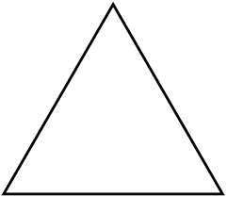



Write missing numbers in the blanks .

1 |  | 3 |  | 5 |  | 7 |  | 9

Cross out the one that is different.

 |  |  | 
 |  | 

Colour the fat object.
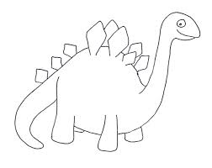 | 

Count and write in the box given below.







DAV Public School
Sector VI, Dwarka, New Delhi

Ref.no. _________________________ Date _________
Subject- EVS
Name _________________________ Class- Pre School ____

Draw a line from the mode of transport to the place it travels.
