DAV PUBLIC SCHOOL CNADRASEKHARPUR, BBSR-21
POST SUMMER VACATION TEST – 2022-23
CLASS – XII
SUB : PHYSICS
Time : 2Hours. MaximumMarks:35

General Instructions :
- This question paper contains 14 questions.
- Question No 1 to 3 carries 1 mark each.
- Question No 4 to 8 carries 2 marks each.
- Question No 9 to 12 carries 3 marks each
- Question No 13 is a case based questions and carries 5 marks.
- Question No 14 carries 5 marks and has a choice.
- The value of $ε_{0}=8.85×{10}^{-12}C^{2}/N.m^{2}$.

- Force of attraction between two-point charges placed at a distance ‘d’ is F. What distance apart should they be kept in the same medium so that force between them is F/3? [1]
- Why two electric field lines never cross each other at any point? [1]
- At a point A, there is an electric field of 500 V /m and potential difference of 3000 V. What is the distance between the point charge and A.? [1]
- Calculate the amount of work done rotating a dipole, of dipole moment 3x10⁻⁸ cm, from its position of stable equilibrium to the position of unstable equilibrium, in a uniform electric field of intensity 10⁴ N/C.
[2]
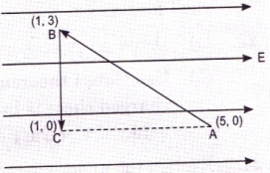
- A test charge ‘q’ is moved without acceleration from A to C along the path from A to B and then from B to C in electric field E as shown in the figure.
Calculate the potential difference between A and C. [2]

- A charge 10C is placed at a centre of a cube of side 10cm. What is the flux linked with the cube? [2]
- Four-point charges $q_{A} = 2$ μC, $q_{B}= –5$ μC, $q_{C} = 2$ μC, and $q_{D}= –5$ μC are located at the corners of a square ABCD of side 10 cm. What is the force on a charge of 1 μC placed at the centre of the square? [2]
- An infinite line charge produces a field of 9 × 10⁴ N/C at a distance of 2 cm. Calculate the linear charge density. [2]
- Define electric dipole moment. Write its S.I. unit. Derive an expression for the electric field intensity at any point on equatorial line of a short electric dipole. [3]
- A charge array known as an electric quadrupole is shown in the diagram. For a point on the axis of the quadrupole, obtain the dependence of potential on r for r/a >> 1, and contrast your results with that due to an electric dipole, and an electric monopole (i.e., a single charge). [3]

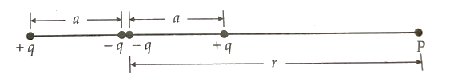
- A thin conducting spherical shell of radius R has charge Q spread uniformly over its surface. Using Gauss’s law, derive an expression for an electric field at a point (i) outside, (ii)on the surface, (iii)inside the shell. Draw a graph of electric field E(r) with a distance r from the centre of the shell for 0 ≤ r ≤ ∞. [3]
- Derive an expression for the potential energy of a dipole in a uniform electric field. Discuss the conditions of stable and unstable equilibrium. [3]

ELECTRIC SHOCK: [5]


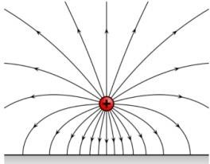

An electric field is a physical field that exerts force on all other charges in the field either by attraction or by repulsion. Electric field and magnetic field are both manifestations of electromagnetic force. The electric field can be visualized with a set of lines whose direction at each point is the same termed as lines of force. Electricity is always for a way to get to the ground. The birds are not touching the ground or anything in contact with the ground.
- Pick the true statement about electric field lines
    - it provides information about the direction of electric field
    - it provides information about types of charge
    - it provides information about field strength
    - all of the above

- The electric field lines due to a single negative charge are represented by

(a)



(b)


(c)

(d)

- The physical quantity that has the unit newton per coulomb is
(a) electric charge (b) electric field (c) electric force (d) electric potential
- Two charges +5µC and +10µC are placed 20 cm apart. The electric field at the midpoint between the two charges is
(a) 4.5 × 106N / C towards +5µC (b) 13.5 × 106N / C towards +5µC
(c) 4.5 × 106N / C towards +10µC (d) 13.5 × 106N / C towards +10µC
- A parrot comes and sits on a bare high-power line. It will
(a) experience a mild shock (b) experience a strong shock
(c) get killed instantaneously (d) not be affected practically
14) (i) Two large, thin metal plates are parallel and close to each other. On their inner faces, the plates have surface charge densities of opposite signs and of magnitude 𝜎. What is E:
- in the outer region of the first plate,
(b) in the outer region of the second plate, and
(c) between the plates?
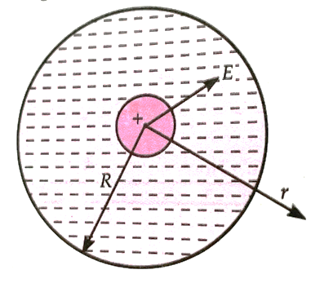
(ii) An early model for an atom considered it to have a positively charged point nucleus of charge Ze, surrounded by a uniform density of negative charge up to a radius R. The atom as a whole is neutral. For this model, what is the electric field at a distance r from the nucleus? [5]

OR
- A Charge ‘q’ is distributed uniformly over a ring of radius ‘a’. Obtain the expression for electric field at a point on the axis of the ring.
- An electron falls through a distance of 1.5cm in a uniform electric field of value 2 X10⁴ N/C. When the direction of electric field is reversed, a proton falls through the same distance. Compare the time of fall in each case. [5]

