DAV PUBLIC SCHOOL CHANDRASEKHARPUR, BBSR-21
POST SUMMER VACATION TEST (2023-24)
CLASS- XII
SUB: PHYSICAL EDUCATION
Time Allowed: 1$\frac{1}{2}$ Hours Maximum Marks: 35
General Instructions:
- The question paper consists of 5 sections and 17 questions.
- Section A consists of question 1-9 carrying 1 mark each and is multiple choice questions. All questions are compulsory.
- Section B consists of questions10-12 carrying 2 marks each and are very short answer types and should not exceed 60-90 words. There is Internal choice available.
- Section C consists of questions 13 & 14 carrying 3 marks each and are short answer types and should not exceed 100-150 words. There is Internal choice available.
- Section D consists of question no 15 carrying 4 marks each and are case studies. There is internal choice available.
- Section E consists of questions 16 & 17 carrying 5 marks each and are short answer types and should not exceed 200-300 words. There is Internal choice available.

SECTION-A (01 MARKS)
- The benefits of Intramural competition is/are 1
  - Psychological satisfaction b) Opportunity for participation
c) Development of moral values d) All of the above
- Which of these in not an objective of organizing sports day? 1
  - All round development of students. b)Development of leadership quality
- Development of social value. d)Advertisement of product
3. Match list –I with List-II and select the correct answer from the code given below. 1
LIST- I | LIST -II
- Intermural tournament | - Regulates the rules of game
- Extramural tournament | ii. Within the walls of institution
- Secretary of tournament | iii. Does all planning of tournament
- Technical Committee | iv. Outside the institution
CODES
 | i | ii | iii | iv
a | 4 | 1 | 3 | 2
b | 3 | 2 | 4 | 1
c | 2 | 3 | 1 | 4
d | 1 | 4 | 2 | 3

4. League- cum –knock-out is a part of which tournament? 1
a) Knock-out b) Round Robin c) transverse plane d) Combination
5. Which of the following factors may enhance the chances of osteoporosis among 1
female athletes?
a) Insufficient calcium in the diet b) Eating disorder c) Amenorrhea d) All of the above
6. Lordosis can be corrected by 1
a) Back word bending exercise b) Forward bending exercise
c) Side ward bending exercise d) All of the above
7. In bow legs deformity there is. 1
a) Wide gap between knees b) Plane foot sole c)Knees collide with each other d) Bending to side ward.
8. Postural deformity of kyphosis is commonly known as: 1
a) Hollow back b) Hunch back c) knock- knee d) Side ward bending
9. Given below are two statements, one of which is labelled as Assertion(A) Reason (R) 1
Assertion(A): In India, women’s participation in sports in quite less
Reason(R): Indian society still does not promote or accept women’s participation in sports.
Which one of the following statement is correct.
- Both A and R are true and R is the correct explanation of A.
- Both A and R are true, but R is not the correct explanation of A.
- A is true, but R is false
- A is false, but R is true.
SECTION –B (02 MARKS)
10. Discuss any four objectives of Intramural. [ 0.5x 4]
11. Elaborate any two functions of sports management in brief. [1+1]
12. Suggest four corrective measures for kyphosis [0.5x4]
OR
Suggest any four correct measures for flat foot.
SECTION –C (03 MARKS)
13. Differentiate between menarche and menstrual dysfunction. [1.5+1.5]
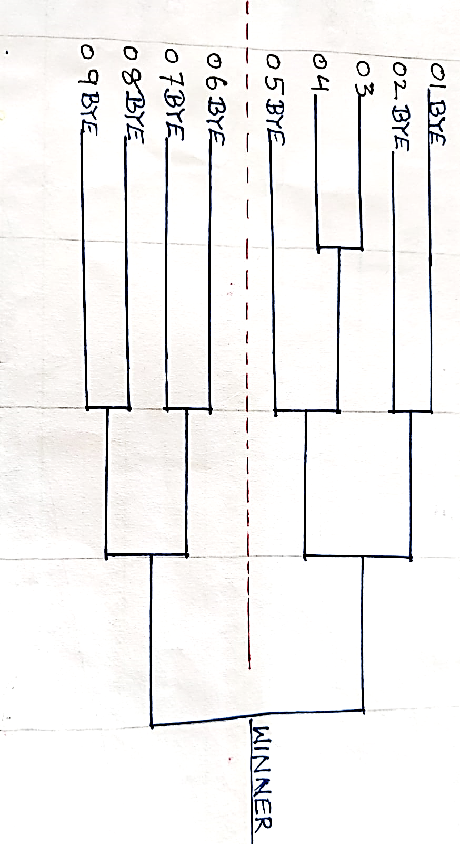
14. What does league tournament mean? Draw a single league fixture for 07 teams in using cyclic method.
OR
What is seeding. Draw a knock out fixture for 9 teams, in which two teams are seeded. [1+2]
SECTION-D (04 MARKS)
15. DAV public School, Chandrasekharpur could shoulder the responsibility in organizing DAV Zonal Basketball tournament, in which 9 teams participated. [1x 4]

On the basis of above given picture answer the following questions.
- The first bye goes to team no_________.
- The formula for calculating the total no of byes is__________.
- The 3rd byes goes to the team no______.
- The formula for calculating the no of round is_____.
OR
The for formula for calculating the no pf teams in upper half is___________.
SECTION –E (05 MARKS)
16. What does knock-out tournament mean? Draw a knock-out fixture for 11 teams with all computations. OR
Define combination tournament. draw a fixture of 16 teams using knock-out cum league method.
[1+2+2]
17. Discuss in detail about common postural deformities by making the flow chart. Explain any three corrective measures for Lordosis. [2+3]

